Biodiversity Lab #2 Land Plants

Part I: Bryophyta
Go to : http://www.youtube.com/watch?v=xbSZbd02UEg&feature=related and this short one if you want http://www.youtube.com/watch?v=kBPLKUTtXBM&feature=fvwrel to answer the questions below. Draw structures whenever possible.
- Moss have adapted to survive life on land by evolving what two features?

- How do sperm move? How do they know where to go? What kind of oriented movement is this?

- Like their algal ancestor, moss have what kind of life cycles? Name the ancestor:

- What are the haploid plants called
- Sperm and eggs are created by mitosis or meiosis?
- Where does the zygote reside?
- What structure grows from the zygote? Is it diploid or haploid? Draw a picture.

- What process does the structure undergo to produce spores?
- Once spores reach a suitable environment, a protonema grows which looks incredibly similar to _______________.
- Name the structures that allow the gametophytes to secure themselves to a substrate?

Part II: Microscope activity: Slide Marchantia
be able to discern between the Archegonium and Antheridium, Sporophyte and gametophyte.
- Identify whether the gametophyte or sporophyte is the dominate part of the life cycle for moss.
- Are Moss vascular or nonvascular? So why are they considered plants?

Part III: : Seedless Tracheophytes: Pteridophyte: Fern
http://www.youtube.com/watch?v=c4YtOT0Z6Ek&feature=related

- Are these true vascular plants? Explain how they are classified.

- What is the common or dominant stage of the fern life cycle? Draw a pic. What is stored on the underside? Why the underside?

- Draw a picture of the sporophyte in cross section. Name the layers and what is their function?

- Are the spores diploid or haploid?
- What is the function of sporopollenin?

- What is the function of the annulus? How does it work: keep it short but this was just too cool!!!

- When the spores reach a suitable environment they grow into a bisexual heart shaped __________________ called a prothallus. What is the notch?

- Name the structures that the gametophyte uses to attach to a surface.

- Where are the female reproductive structures of the gametophyte located?

- What determines whether the plant will self fertilize or cross-fertilize? What is the advantage of this?

- What is the function of antheridiogen?

- Water stimulates the release of sperm. What do you notice about the sperm? What are types of organisms does this look like?

- Water also causes what to happen to the female part of the fern?

- What major shift occurs from the moss to the fern in the life cycle?

- Explain how ferns have spread farther away from water than moss.

See the jars of the other Phyla: Psilophyta (whisk ferns) Lycophyta (club mosses) Sphemophyta (horsetails) Pterophyta (ferns)

What are shared traits?

***Be able to describe the life cycle of a fern; distinguish between gametophyte and sporophyte generations and identify which is the dominant stage. Which are haploid and diploid? Be sure you know what a prothallus is and what it contains.

Part IV: Gymnosperms: Coniferophyta, Cycadophyta, Ginkgophyta and Gnetophyta

List the characteristics of Gymnosperms: tall evergreen trees
- What kind of specialized leaves do gymnosperms have? What is evolutionary advantage?

- What are the reproductive structures called?
- Are these seeds naked or covered?
- How does the sperm gain access to the egg?

- Are these true vascular plants?

http://www.youtube.com/watch?v=D9byVQxvMXs

- The pine tree is actually what dominant part of the life cycle? Is it 2n or n

**** Be able to describe the relationship between microsporophyll, microsporangium, microspore, microgametophyte and pollen. Be able to describe the relationship between ovule, megasporangium, megaspore and seed.

Part V: Angiosperms: Be able to do the following
1. Distinguish between a monocot and dicot flower types.
http://www.youtube.com/watch?v=4uq5ybc4vts
leaves, stems and cotyledons

2. Label the parts of the flower. Know which is male and female and 2n or n. Differentiate the difference between pollination and fertilization.
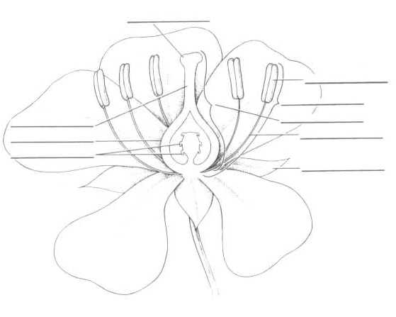
3. What is the dominant stage of the life cycle for Angiosperms? Is this similar or different from the Gymnosperms?

http://www.youtube.com/watch?v=fYSxgVGtMmU&feature=related

4. Anthers undergo what process to make their reproductive cells? Are these male or female?

5. The Sticky stigma is located on top of the ____________ which conatins the _______________.

6. When pollen reach the sticky stigma a pollen tube grow and two nuclei move down. What is the function of two nuclei?

7. This special mode of reproduction found only in angiosperms is called:

8. Discuss the major difference between pollination processes for the angiosperms form the gymnosperms?

9. BRIEFLY Discuss the evolutionary advantage of the angiosperm reproduction strategy.

10. How can the flower prevent self fertilization? Can flowers self pollinate. Advantages to either of these?

http://www.youtube.com/watch?v=bwCpQflmQG4&feature=related
11. When you eat fruit you are eating what structure?

12. When you sneeze from pollen, what has gone up your nose? I know gross but you will remember!

Post lab questions:
- What three major advances are obvious among the vascular seed plants?
- Are ferns heterosporous or homosporous? __________________ Gymnosperms? _________________ Angiosperms? ___________________
- Complete the table
Structure | Fern archego-nium | Moss anther-idium | Fern leaf | Moss leaflet | Pine pollen | Angiosperm  Mega gameto-phyte | Angiosperm  Micro-sporangium | Pine Tree | Flower
N or 2n
Gametophyte or sporophyte

